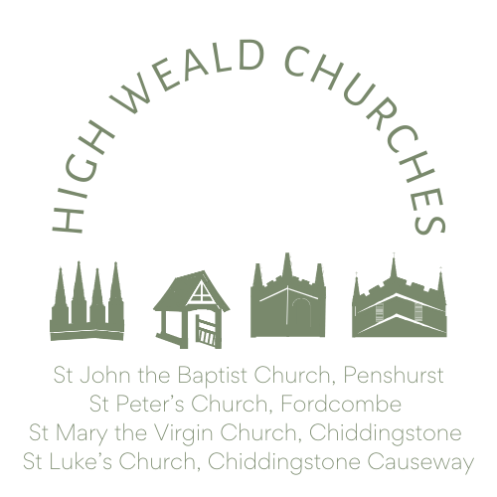
Child(ren) Baptism Application Form
High Weald Benefice of Churches
(Penshurst, Fordcombe and the Chiddingstones)

We are delighted you have come to us to celebrate the beginning of your child(ren)’s journey. A Christening service (also known as Baptism) places your child(ren)’s life in the context of their life in Jesus and in community. It celebrates the promises of God to be there for your child(ren) for the rest of their life, as their parents, godparents and friends and relations hope to be, and establishes them in the community of the Church, both locally and around the world.
Some of the questions we ask below are clarified in the notes found at the end of this document.

Date of Baptism
Time
Church  (please indicate which church) | St John the Baptist, Penshurst  St Peter’s Church Fordcombe  St Mary the Virgin Chiddingstone  St Luke’s Chiddingstone Causeway
Approx no. attending
Special access needs | Yes / No

Details of Child(ren) | Full Name | Date of Birth | Sex
Child 1 |  |  | Male/Female/Prefer not to say
Child 2 |  |  | Male/Female/Prefer not to say
Child 3 |  |  | Male/Female/Prefer not to say

Details of parent | Full Name | Relationship | Occupation | Legally Responsible
Parent 1 |  |  |  | Yes / No
Parent 2 |  |  |  | Yes / No
Parent 3 |  |  |  | Yes / No
Is there anyone else legally responsible for this/these child(ren)? |  |  |  | Yes / No
Have they consented to this service? |  |  |  | Yes / No

Contact details for this booking

Name, if different from above
Address:
Telephone number:
Email address:

Godparents | Full Name | Baptised | Godchild
Godparent 1 |  | Yes / No
Godparent 2 |  | Yes / No
Godparent 3 |  | Yes / No
Godparent 4 |  | Yes / No
Godparent 5 |  | Yes / No
Godparent 6 |  | Yes / No

Additional Notes:

Data Privacy Policy
For further information about our use of your data, please see the Benefice website.
Keeping in touch
Please indicate whether we can contact you regarding further events / campaigns within the Benefice: Yes / No
Useful contact details:
Rector: rector@highwealdchurches.org.uk
Associate Priest: associatepriest@highwealdchurches.org.uk
Administrator: office@highwealdchurches.org.uk
Please return completed Baptism Application form to the Benefice Office: office@highwealdchurches.org.uk
For administration:
Officiant:
Date, time and church confirmed:

NOTES:
Date and time– we will do our best to find a date that works for you and the more notice you give us the easier this will be. We encourage you to have your Christening during the main Sunday service at 10am, but this may limit the dates available in a specific church. We also realise it is sometimes difficult to gather friends and family from near and afar for 10.00 am, so it is possible to arrange a time after the main service.
Church – we are a family of three parishes, four churches and a graveyard Chapel. Just let us know which church you are wanting to attend.
Special access needs – all our buildings are older than modern planning regulations, but we do have a ramp at St John the Baptist in Penshurst, a good car park at St Luke’s, Chiddingstone Causeway, and level access at St Mary the Virgin, Chiddingstone. We will do our best to meet any particular access needs of your family and friends; advance warning to accommodate wheelchairs would be appreciated.
Parents’ legal responsibility – while a variety of people might have parental roles for your children, Canon Law requires that the person presenting them for Baptism has, what is now described in law, as parental responsibility. Only one parent with parental responsibility is needed to present a child for baptism. However, any other person with parental responsibility should be informed of the decision and, if they object, be given proper time to state and pursue their objection.
Godparents - There is no upper limit to the number of godparents. There are normally three godparents, two being the same sex as the child and at least one of the opposite sex. This is to comply with Canon law, which is older than the current nuances of gender identity, so the interpretation of this rule lies with the applicant. A parent may also be a godparent, but there should be at least one other godparent who is not a parent.
Each godparent must be baptised (i.e. Christened), however, a joint baptism with the child could be performed. Please get in touch to discuss.

