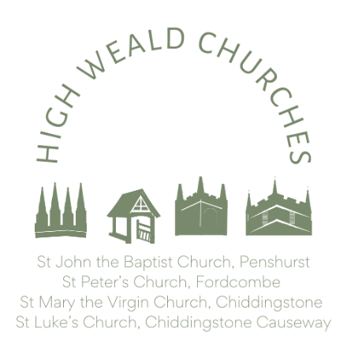
To our Benefice Friends,

This week’s newsletter gives lots of information about services, and local and national events in church.

Upcoming services
Sunday 24th March: Palm Sunday
1000 All Age Service for Palm Sunday (with Donkey), led by Forest Church, at St Luke’s Church

1700 All Age Service at Fordcombe Village Hall. Preceded by The Village Tea running 1500-1700

1800 Holy Communion with a Reading of the Passion Narrative at St John the Baptist’s Church
Thursday 28th March: Maundy Thursday
1030 The Chrism Eucharist (President & Preacher: The Bishop of Rochester) at Rochester Cathedral
(This is a service to bless the oils we use for anointing, and the ministers of the Church, and you are warmly invited to attend.)
1900 Holy Communion and Tenebrae at St John the Baptist’s Church
(This is a service of readings and reflection, during which the lights are slowly dimmed, as we move from the Last Supper to Jesus Arrest in the Garden.)
Friday 29th March: Good Friday
0900 Morning Service at St Luke’s Church
0945 Hot Cross Buns at St Luke’s Room
1015 Walk of Witness from St Luke’s to St John the Baptist’s Church (arriving c1130)
1400 An Hour at the Cross at St Peter’s Church
(from c.1410 St Mary’s will be open for prayer, with a priest present.)
Sunday 31st March: Easter Day
0800 Holy Communion at St Peter’s Church
1000 Sung Holy Communion at St Mary the Virgin’s Church
1000 All Age Holy Communion at St John the Baptist’s Church. The service will include an Easter Egg hunt and crafts for children.

Sunday 7th April: Second Sunday of Easter (“Low Sunday”)
1000 Holy Communion at the Church of St John the Baptist

News
This week the parishes are in a period of calm between two rather busy patches. Last weekend five baptisms surrounded the main Sunday services. We pray for all of those new members of The Church of England and their families. Each baptism was the result of a family attending another occasional office in the parish. It is such a blessing to see how people’s faith journeys develop. Even the sadness of a family funeral can result in a joyful return to church later for a baptism or a wedding; and similarly, a joyful occasion can help people to see our churches as places of welcome and safety when life becomes tougher. It is an honour to minister at all points in people’s life journey.

Sunday marks the beginning of Holy Week and our services and other activities are listed above. We have tried to ensure that within Holy Week there are a range of service styles spread across all four churches.

On Easter Day we will begin our second year of our liturgy review process with a second draft service for the season of Easter to Pentecost being used. We have responded to feedback received over the last year so that each booklet in its second draft should address any matters raised with us. The fresh liturgies being trialled across two years are a chance to experience the rich variety of liturgy available in The Common Worship portfolio of services. This second seasonal draft includes clearer rubrics and more complete texts for te congregation to follow during The Eucharistic Prayers. As requested in the liturgy review meetings help over five months last summer, the booklets recognise some differences between the parishes in terms of readings and mass settings. Hopefully you will notice that the printing is clearer. Enlarged copies of service books will be available for those who find the standard text too difficult to read. Constructive feedback remains a welcome part of the review process. Please do drop us an e mail if you would like to suggest further improvements.

Forthcoming Meetings
A reminder that the Annual Parish Meetings takes place in Chiddingstone Village Hall on 14th April straight after the morning service. See last week’s newsletter for more details.

Life Events

We hold in our prayers Emma Welch, whose funeral we will be hosting this week at the Church of St Mary the Virgin, on Wednesday at 11am. We pray, too, for her young family. Pray, too, for those whose year’s mind falls at this time:

23-Mar
24-Mar
25-Mar | Irene Cadney
26-Mar
27-Mar
28-Mar
29-Mar
30-Mar | Maisie Ellen Williams
31-Mar | Molly Langridge

Rest eternal grant unto them, O Lord, and let light perpetual shine upon them.

Safeguarding
A reminder to get your training done by the Annual Meeting, please and to let us have your certificates, so we can get a good picture of our cover.
(We’ve set a deadline of the APCM for training to be completed, so that we can start the new administrative year on a firm footing. But why – I hear you ask (no really) – do we need to do this training if we’re not in a leadership role? Here are five reasons provided by TES:
1. Learn who might be vulnerable
2. Recognising tell-tale signs of abuse and neglect
3. Improve our communication with one another
4. Increase trust in the Church
5. Enable us to respond well to disclosures of abuse or neglect.)

Do please, whether you are visible in our ministry or not, have a look at the training offered. It is really very good.

Best wishes for the week ahead,

Lisa & Lindsay

Useful links:
Governance 2024 March update.docx
Safeguarding training

Learning and growing:
Some upcoming courses and events in the wider diocese -
'Let's end poverty' webinar
23 April (5.30pm to 6pm) hosted by Bishop Simon, aimed at people who want to take practical steps towards a better vision for the UK’s poor. Register to find out more.
PLANS TO MARK WOMEN'S MINISTRY - This year is the 30th anniversary of the first women in the Church of England to be ordained as priests. To mark this special occasion, and to give thanks for all women’s ministry, a service of Evensong is being planned for Sunday 30 June, at Rochester Cathedral. More details will be shared soon, however, in the meantime, please do save the date.

If you know anyone who would like to be added to our weekly mailing, do let us know (and similarly let us know if you’d like to come off, though we’d be sad to see you go). If you’d like to contribute to the work of the benefice, you can go to our parish giving page via the www.parishgiving.org.uk website (we’d be very grateful).
.

