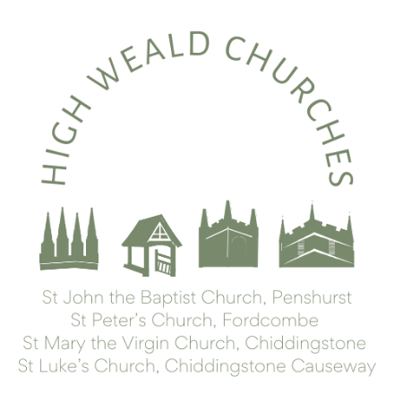
To our Benefice Friends,

It has been a busy week this week, with many meetings and gatherings. The Joint Council met on Thursday and are now focusing their efforts on preparing for the annual meeting – 14th April at 1100 in Chiddingstone Village Hall. There will be much to share, about what we’ve been doing this year, and about our plans for the coming year, and we’d like as many there as possible.

As part of the preparation, Rev’d Lisa has prepared a paper describing the pattern of church governance, forthcoming vacancies in the benefice and a summary of the church representation rules and how they apply to us in 2024. It is a bit of a long read (sorry!) but she hopes the document will help everyone to understand how decisions are made and how to be involved in parish life. You are warmly invited to stand for one of the upcoming vacant roles all of which are described in the paper.
Governance 2024 March update.docx

In the meantime, if you would like to make constructive suggestions for improvement in any aspect of church life, the clergy would be delighted to talk to you. Please speak to us in person perhaps after a service or drop us an e mail to arrange an appointment.

We are delighted to introduce our shiny new administrator. We are grateful to Tracy for all that she has done to support us over the past year, and she has now handed the baton over to Tabby, who will have the most phenomenally steep learning curve over the next few weeks. Please be kind! A warm welcome, to Tabby. We are so delighted to have you join our Benefice Team.

On Friday the reception class from Penshurst school, and their families, visited church for a welcome, refreshments and to receive a children’s bible donated by a parishioner for each child. The children and their families had a wonderful time in church, and we look forward to welcoming them as they move through the school. Next week Rev’d Lisa will be leading worship in all three benefice schools and looks forward to talking with the children and school staff.

We have a number of Christenings coming up as the season turns. Please hold Theo, Lily, Toby, Connie-Rae, and their families in your prayers as they mark this important stage in the pilgrimage of their life. In a similar vein, you’ll have noticed we’ve started calling banns again, as the wedding season is about to begin. Please pray for our wedding couples as they, too, begin a new chapter together. A wedding preparation session today (Saturday) is being held in Fordcombe Village Hall.

More solemnly, we hold Emma Welch, whose funeral we will be hosting shortly, and her young family in our prayers. Pray, too, for those whose year’s mind falls at this time.

We have so many people pass through our doors in this place, we are really blessed in the opportunities that offers for us share God’s love. As the weather warms up and the visitors increase, do pray for all those who will pop their heads into our buildings, that they will find there something of the love that draws us and holds us.

Best wishes,

Lisa & Lindsay

Upcoming services
Sunday 10th March: Mothering Sunday
0800 Morning Prayer at Saint Mary’s
(this will be more Lenten in character, with no references to Mothering Sunday)
1000 All Age Holy Communion, with distribution of posies, at St Peter’s
Sunday 24th March: Palm Sunday
1000 All Age Service for Palm Sunday (with Donkey), led by Forest Church, at St Luke’s
1800 Holy Communion with a Reading of the Passion Narrative at St John the Baptist’s
Thursday 28th March: Maundy Thursday
1030 The Chrism Eucharist (President & Preacher: The Bishop of Tonbridge) at Rochester Cathedral
(This is a service to bless the oils we use for anointing, and the ministers of the Church, and you are warmly invited to attend.)
1900 Tenebrae at St John the Baptist’s
(This is a service of readings and reflection, during which the lights are slowly dimmed, as we move from the Last Supper to Jesus Arrest in the Garden.)
Friday 29th March: Good Friday
0900 Morning Service at St Luke’s
0945 Hot Cross Bunns at St Luke’s Room
1015 Walk of Witness from St Luke’s to St John the Baptist’s (arriving c1130)
1400 An Hour at the Cross at St Peter’s
(from c.1410 St Mary’s will be open for prayer, with a priest present.)
Sunday 31st March: Easter Day
8am Holy Communion at St Peter’s
1000 Sung Holy Communion at St Mary’s
1000 All Age Holy Communion at St John the Baptist’s
Learning and growing:
Some upcoming courses and events in the wider diocese -
An Introduction to Christian Meditation
Saturday 23rd March 2024 10am - 3pm
at St Benedict’s Centre, West Malling ME196JX
For more information, see the Diocesan website.

'Let's end poverty' webinar
23 April (5.30pm to 6pm) hosted by Bishop Simon, aimed at people who want to take practical steps towards a better vision for the UK’s poor. Register to find out more.
PLANS TO MARK WOMEN'S MINISTRY - This year is the 30th anniversary of the first women in the Church of England to be ordained as priests. To mark this special occasion, and to give thanks for all women’s ministry, a service of Evensong is being planned for Sunday 30 June, at Rochester Cathedral. More details will be shared soon, however, in the meantime, please do save the date.

If you know anyone who would like to be added to our weekly mailing, do let us know (and similarly let us know if you’d like to come off, though we’d be sad to see you go). If you’d like to contribute to the work of the benefice, you can go to our parish giving page via the www.parishgiving.org.uk website (we’d be very grateful).
.

